TEST CASES

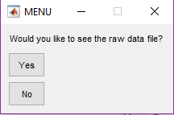Test Case 1:

1. Click ‘Yes’ on the first menu that opens
2. In the next menu that opens click ‘Continue’ – This should open and excel file

called *Dataset*

1. 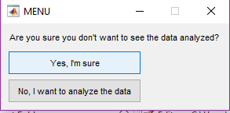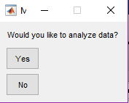When asked, ‘Would you like to analyze data?’ click ‘No’
2. 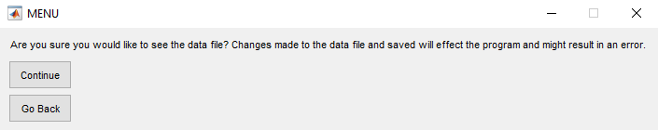When asked for confirmation, click ‘Yes, I’m sure’ – Program Terminated

Test Case 2:

1. Click ‘No’ on the first menu that opens
2. When asked, ‘Would you like to analyze data?’ click ‘Yes’
3. A new menu will pop up with 5 different options. Select

Option 1 – Information will be displayed in the command window

1. When asked ‘Would you like to choose another option?’ click ‘Yes’
2. Continue to do this for each of the 5 options
3. The final output and graphs are displayed below.

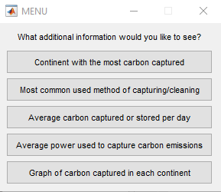

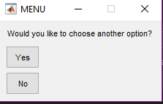

OUTPUTS:

